Figure 1. Patient’s left hand – with a characteristic ‘wrist drop’ and ‘finger drop’. Even without examining, it’s evident the patient has intact power in the shoulders and in elbow flexion, given the position she’s adopted.
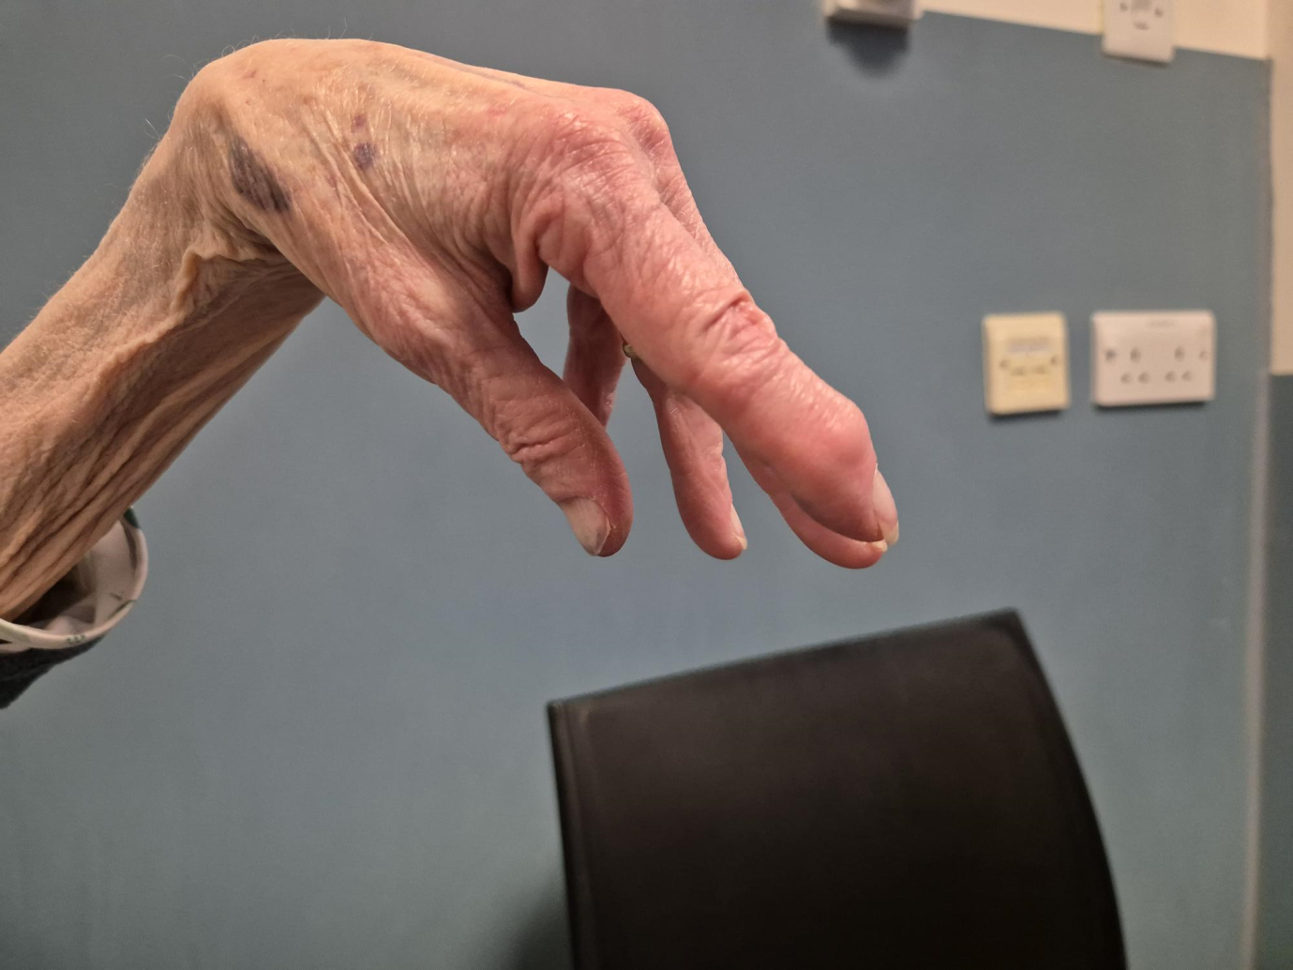

Figure 2. Cortex labelled on axial T2 MRI brain. The motor hand areas can be seen in both pre-central gyri. Lesions here such as infarcts can produce hand paralysis.

Figure 3. Elbow anatomy, showing only skeleton.
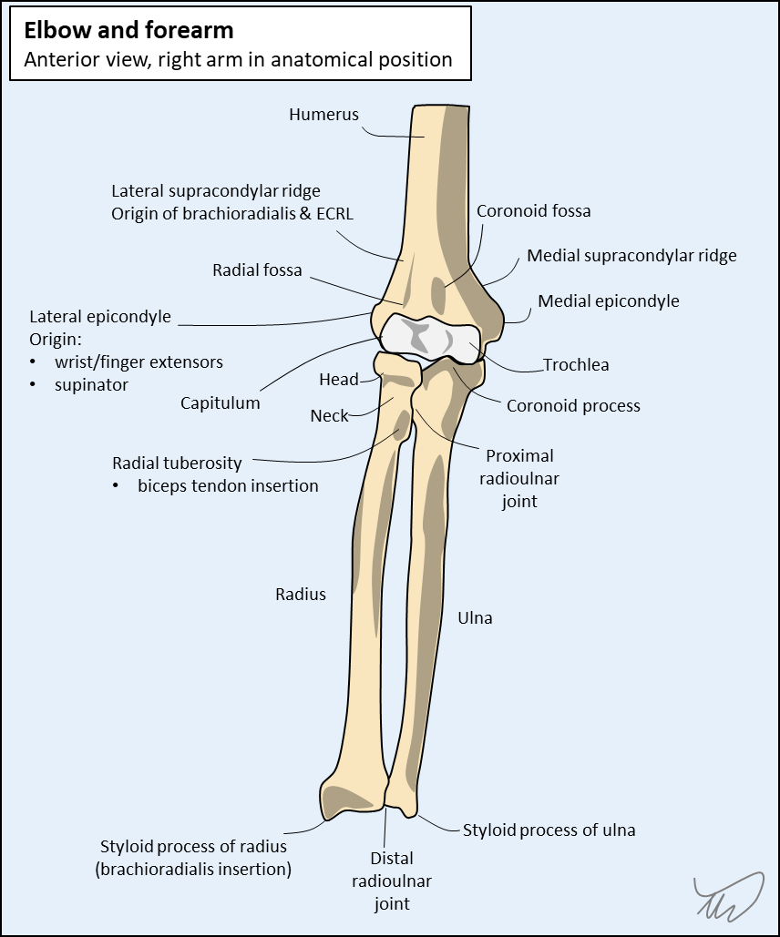
Figure 3B. The radial nerve pathway is shown as it emerges around the lateral aspect of the distal humerus. The separation into deep and superficial branches can be seen below the elbow. The arcade of Frohse is an important potential entrapment site for the deep branch.
